

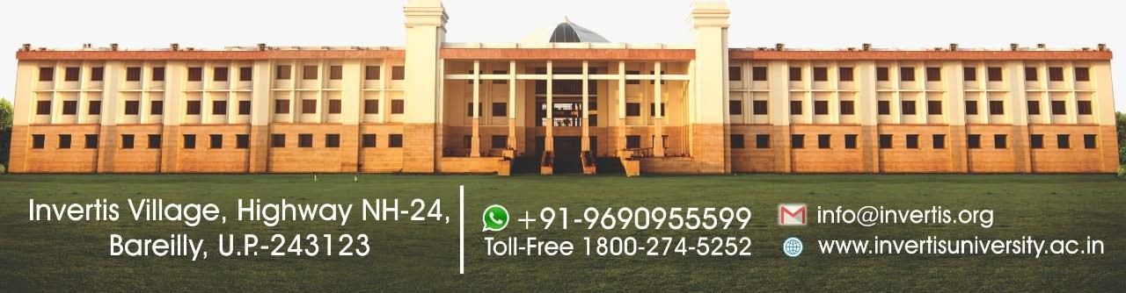



**Attainment of Programme outcomes, Programme specific outcomes and course outcomes**

**NAAC CRITERIA 2.6.2**

[262-CO-PO-attainment.pdf (invertisuniversity.ac.in)](https://www.invertisuniversity.ac.in/pdf/AQAR-2020-21/Criteria-II/262-CO-PO-attainment.pdf)